Steve Burchett
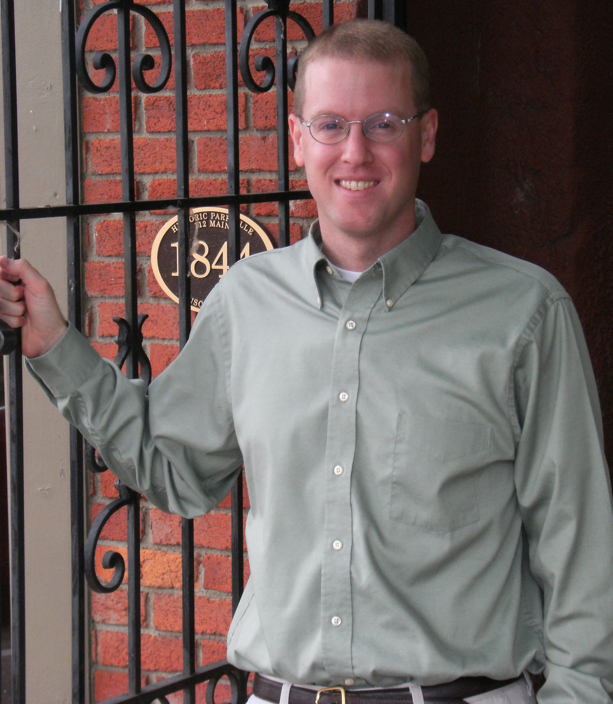
Steve is a seminar leader, writer, and editorial assistant for Christian Communicators Worldwide. Since 2007, Steve has traveled to churches around the country teaching a seminar on childhood conversion, typically staying through Sunday morning in order to preach. He also thoroughly enjoys communicating the Bible at retreats, conferences, and pastor's meetings of various denominations. In addition, Steve loves to teach through writing. He is a co-author of Divorce and Remarriage: A Permanence View, and many of his articles may be found at www.BulletinInserts.org, www.CCWblog.org , and www.CCWtoday.org.

In 1998, Steve earned his B.A. from Cedarville University, followed by a Masters of Divinity in 2001 from The Southern Baptist Theological Seminary in Louisville, Kentucky. For nearly five years prior to serving with CCW, he was the pastor of First Baptist Church of Athens, Ohio.

Along with his current ministry with CCW, Steve serves as an elder in Christ Fellowship of Kansas City (www.ChristFellowshipKC.org), a unique church made up of home congregations in the Kansas City metro area.

Steve married Patty Noble of Westwood, New Jersey, in 1998, and they now have three children: Katie, Luke, and Lilly. You can keep up with Steve's ministry and family by visiting www.ChristCommunicator.com.

Steve Burchett
Steve is a seminar leader, writer, and editorial assistant for Christian Communicators Worldwide. Since 2007, Steve has traveled to churches around the country teaching a seminar on childhood conversion, typically staying through Sunday morning in order to preach. He also thoroughly enjoys communicating the Bible at retreats, conferences, and pastor's meetings of various denominations. In addition, Steve loves to teach through writing. He is a co-author of Divorce and Remarriage: A Permanence View, and many of his articles may be found at www.BulletinInserts.org, www.CCWblog.org, and www.CCWtoday.org.

In 1998, Steve earned his B.A. from Cedarville University, followed by a Masters of Divinity in 2001 from The Southern Baptist Theological Seminary in Louisville, Kentucky. For nearly five years prior to serving with CCW, he was the pastor of First Baptist Church of Athens, Ohio.

Along with his current ministry with CCW, Steve serves as an elder in Christ Fellowship of Kansas City (wwwChristFellowshipKC.org), a unique church made up of home congregations in the Kansas City metro area.

Steve married Patty Noble of Westwood, New Jersey, in 1998, and they now have three children: Katie, Luke, and Lilly. You can keep up with Steve's ministry and family by visiting www.ChristCommunicator.com.

